Appendix F – Naming and Mapping Standards

All vector spatial data shall be delivered in shapefile (.shp, .dbf, .shx, .prj) and projected to B.C. Albers;
- Central Meridian: 126 0 0
- Latitude of Origin: 45 0 0
- 1st Standard Parallel: 50 0 0
- 2nd Standard Parallel: 58 30 0
- False Easting: 1000000
- False Northing: 0
- Datum: NAD 83

All Shape files will be delivered to the Ministry in the following standard naming convention:
Shapefile Naming Standards
A standard shapefile will be provided to successful contractors, with standard attribute information, including but limited to; hotspot ID, date, collection method and Latitude and Longitude coordinates in decimal degrees minutes (DDM e.g. -120º 19.450 x 55º 15.360).
Shape file names must follow the conventions as follows:
Example: K20971_20180829_1230_1_p
Chars. 1-2 identify the Fire Zone (K2)
Chars. 3-6 identify the Fire # assigned by Fire Centre Dispatch (0971)
Chars. 7 is an underscore
Chars. 8-15 identify the date in yyyymmdd format (20180829)
Chars. 16 is an underscore “_”
Chars. 17-20 is the hour and min
Char. 21 is an underscore
Char. 22 identifies a version number for the day (1)
Chars. 23 is an underscore
Chars. 24-25 – thematic content indicator. P = Perimeter. X= hotspot xa= heat area ct=contours
This example tells the user:
This data set is in Kamloops Fire Zone 2, pertaining to Fire #0971, collected on August 29, 2018, collected at 1230 pm, it’s the first perimeter collected on August 29, 2018 for this fire.
Note: The version number (character #22) refers to datasets that may be collected more than once in a day. If the next version of a dataset is collected the next day, then the version reverts back to 1.
Note: Spaces are not acceptable in any spatial datasets. The “_” character is used as a space and must be accompanied by metadata to include, but not limited to, title, description, who created the project, how it was created (collection method, software used and versions), date and time of acquisition, altitude, and contact information, projection including Datum and data dictionary for any attributes.

PDF Map Naming Convention
YY <Fire Number> MAP <Theme> <Page Size> <MMMDD>.PDF

Where MMM is the first three (3) letters of the month and YY is the year of creation.

Example: 21 K21001 MAP HOTSPOT 36x48P Jul 30.pdf

PDF export settings should mirror the below screenshot, and PDF map products should be reduced after export to keep file sizes low.
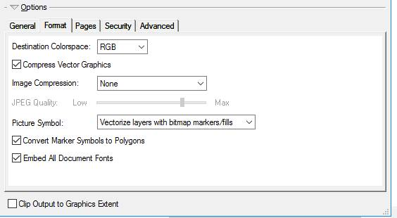
IMAGERY – if the PDF contains imagery add IMG to the file name.
Example: 20 V31176 MAP HOTSPOT IMG 8.5x11P 20200829.pdf

KML/KMZ Naming Convention
<YY> <FireNumber> <Description> <CollectionMethod> <CollectionTimeYYYYMMDD> <CollectionTime HHMM>.KMZ
Example: 20 V31176 Hotspot NonCorrectedGroundGPS 20200829 1230.KMZ

Map Elements
Provide finished map products with topographical data (supplied by the contractor) that is legible at the map scale that the Ministry requests and include the following features:
- orthomosiac/thermal image;
- roads, trails, lakes, rivers, streams;
- north arrow;
- scale bar;
- contour lines;
- fire number, date, time of scan; and
- latitude and longitude for each hot spot/cluster in degrees and decimal minutes
- each hot spot or heat area must have a unique identifier that correlates to the number on the map;
- fire perimeter outline;
- the statement GPS data was captured using NAD 83;
- company name, who produced the map;
- type of camera utilized, camera operator; and
- geographic location and legend.

Map elements and feature symbology will conform to specified standards.
Digital Map
- Includes all features listed above but in digital format (PDF);
- ArcGIS shape files and KML/KMZ files, which need to be delivered in a timely fashion;
- Must be a georeferenced (PDF);
- The fire perimeter will be a polygon and delivered as both shape file and KML or another approved format;
- The hot spot locations will be point data delivered as both shape and KML or approved format;
- Orthomosaic and Infrared mosaic imagery;
- Geotiff and KMZ delivered electronically, and;
- Accuracy of the GPS coordinates to be within 10 meters of target locations.

Data Transfer
- A data transfer service will be provided that is suitable for transfer of large files.
- Upon completion of this contract, the Contractor will return all raw data and completed project files to the Ministry Officer on an encrypted hard drive.
- Data should be sent to BCWILDFIREGEO@gov.bc.ca as well as Fire Centre contact

Sample map product

